Architecture Diagrams
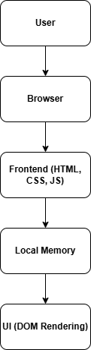
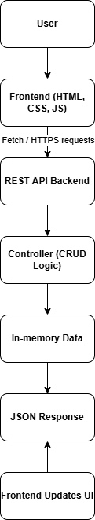
AFTER Integration
BEFORE Integration

